Southern Ocean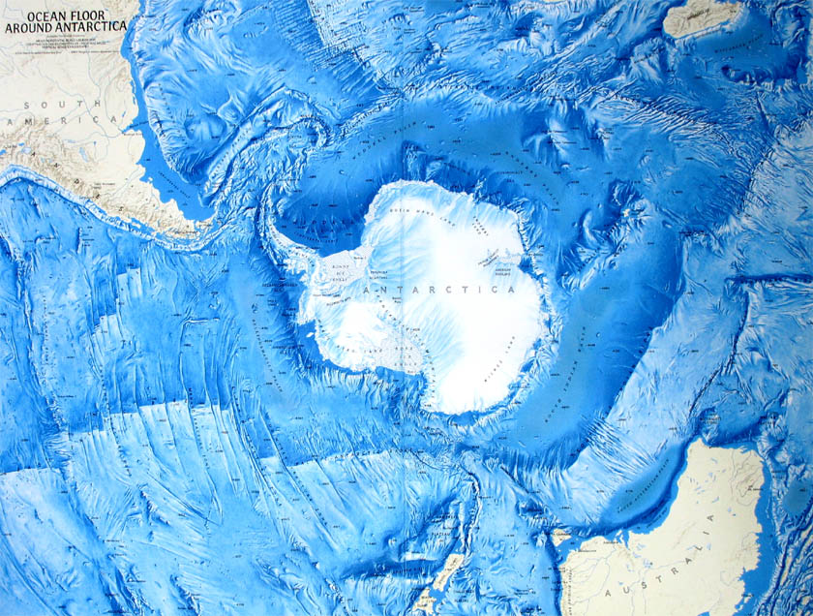

The Atlantic Ocean is the second largest ocean. It stretches from the north at the Arctic Ocean and goes all the way to the Southern Ocean just north of Antarctica. The Atlantic Ocean forms an S-shape between North and South America and Africa.
Size: The Atlantic Ocean is 41.1 million square miles. It covers approximately one fifth of the Earth’s surface.
Average Depth: The average depth of the Atlantic Ocean is 10,936 feet. That is 2.1 miles deep!
Deepest Point: The deepest point in the Atlantic Ocean is the Puerto Rico Trench. It is 5.35 miles deep.
Bordering Countries: The Atlantic Ocean borders 47 countries.
Average Temperature: The temperatures for the Atlantic Ocean range from 28 to 84 degrees Fahrenheit.
Fun Fact: The Atlantic Ocean contains approximately 95,037,420,994,000,000,000 gallons of water.
The Atlantic Ocean is named after Atlas from Greek mythology. Its name can be found in documents dating back to 450 BC.

